**Lab 4 Report – Aaron Bruner**

The purpose of this lab is to implement interactive region growing. The program builds upon two pieces of code given. The plus program allows the user to load and display an image. Plus also demonstrates several GUI and event handling techniques. The region growing code demonstrates growing a region based upon several predicates. These pieces must be integrated into a new program that allows the user to click any location in an image and visualize the results of growing a region there.

Application with no image loaded:

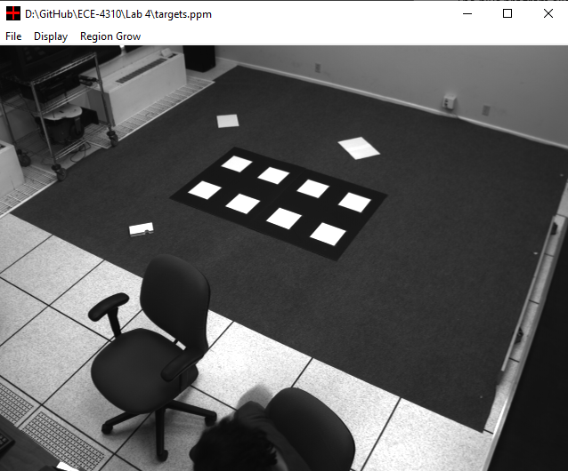

Application with image loaded:

Menu Options Available:

Display:

* Show Pixel Coordinates
* Graphical user interface, text, application, chat or text message

  Description automatically generatedShow Original Image

Region Grow:

* Absolute Difference
* Centroid Distance
* Grow Style
  + Graphical user interface, text, application, chat or text message

    Description automatically generatedPlay
  + Step
* Color
  + Red
  + Green
  + Blue

The absolute difference and centroid difference pop up a dialog box requesting integer values from the user:

* Absolute Difference Graphical user interface, application

  Description automatically generated
* A picture containing text, green, light

  Description automatically generatedCentroid Distance Graphical user interface

  Description automatically generated

Using the following settings we’ll click around the image:

* Absolute Difference : 50
* Centroid Distance : 30
* Grow Style : Play
* Color : Green

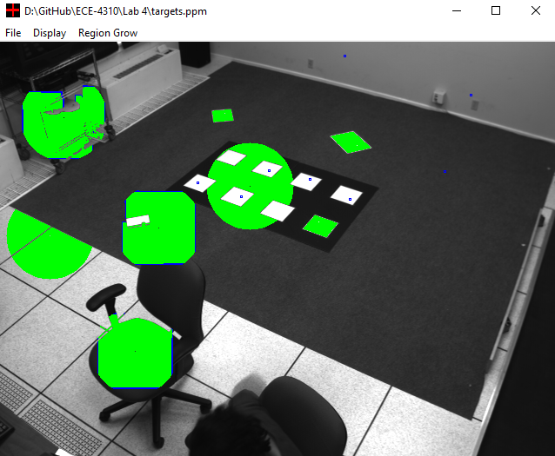

Using the following settings we’ll click around the image:

* Absolute Difference : 50
* Centroid Distance : 30
* Grow Style : Step
* Color : Blue

Not much changes until we start pressing ‘J’

(the activation key)